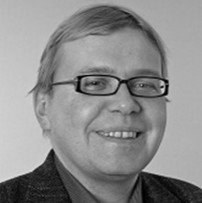
Prof. Jyri-Pekka Mikkola
He received his M.Sc. in Chemical Engineering from Åbo Akademi University, Åbo-Turku, Finland in 1992. After spending a few years at the industry he returned to the academia to complete his PhD at Åbo Akademi University in 1999. Since 2008 he is a professor (Sustainable Chemical Technology) at both Umeå University, Sweden and Åbo Akademi, Finland.
He has co-authored more than 300 scientific articles and holds a number of patents. The principal areas of interest are green chemistry; heterogeneous catalysis; ionic liquid technologies; chemical kinetics; and novel materials. He is involved with two start-up companies, namely ECO-OIL AB and SPINCHEM AB. In 2004 he was appointed as Academy Research Fellow and received 'The Incentive Award' by the Academy of Finland in 2006. In 2009 he received the Umeå University ‘Young scientist Award’ and 2018 the Umeå University’s Baltics price for entrepreneurship.

