Further Implementation of EU Regulation on Volatile Organic Compounds

Terms of Reference
Local STE –Expert for funding programs



This project is financially supported by
The Royal Norwegian Embassy in Belgrade
https://www.norway.no/en/serbia/

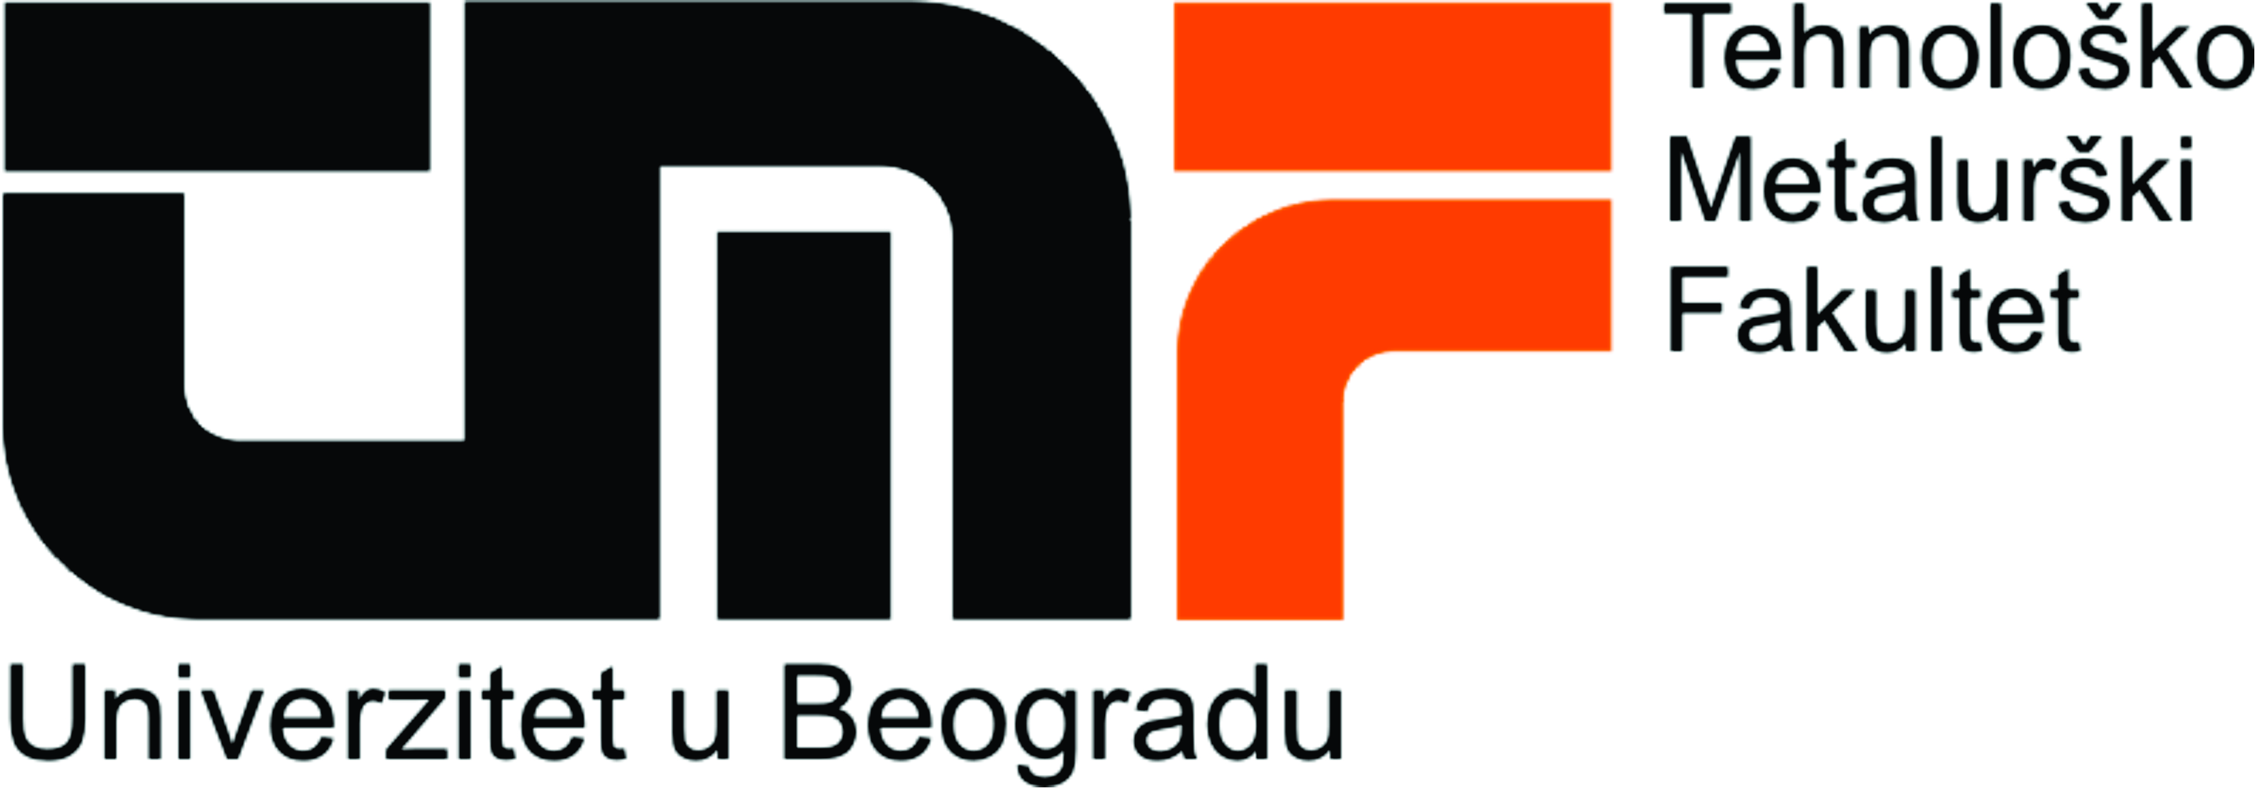


Project is implemented by the Cleaner Production Centre of the Faculty of Technology and Metallurgy
University of Belgrade

Position: Local Short Term Expert – Expert for funding programs– Activity 4 (ref. LSTE/funds)

Description of the project
General objective of the project is to support the Ministry of Environmental Protection of the Republic of Serbia and the Serbian Agency for Environmental Protection in the implementation of Chapter V of Industrial Emissions Directive (IED) regarding pollution from operators utilizing Volatile Organic Compounds (VOC), in accordance with the implementation plan laid down within the process of access to the EU and negotiation Chapter 27.
The project aims to achieve the following specific objectives:
- Enhance the process of accession of Serbia to the EU supporting operators and Institutions in the transposition and implementation of specific requirements of Industrial Emissions Directive applicable to operators using Volatile Organic Compounds (VOC);
- Contribute to improve the capacity of Serbian's Ministry for Environmental Protection in governing and reducing the pollution derived from the use of VOCs;
- Foster socio-economic development of Serbian operators, particularly SMEs, by increasing their skills and capacity in the field of protection of the environment from VOCs and improving their competitiveness.
This project represents a further support to the Ministry of Environmental Protection (MEP) in carrying out the Implementation Plan for IED providing them with a functional IT system for reporting obligations and additional training needed to increase the capacity of operators and inspectors to fulfill their obligations according to Chapter V of IED.

Description of activities

Activity 4 – Information and communication about VOC Regulation

Serbian Institutions and public suffer a significant lack of knowledge about VOC substances, as well as operations and cleaning technologies related to organic solvents, and an emerging need for information is being expressed at every level. Being this topic very specific, it is important to circulate up-to-date information and to create a proactive network where these data can be shared, possibly opening the doors to experiences from other Countries where this Regulation has been implemented for a longer period.

For these reasons, this activity aims at creating a reference point on VOC regulation where technical contents will be created and disseminated and that will be available for operators and Public Authorities as a technical support for administrative, technological and informative issues. The creation of an Info Centre and a Helpdesk will try to give an answer to the increasing request for support and will contribute to achieve a higher and more effective level of compliance with the Regulation.

Job description:
The expert will be required to perform 1 or more of the following tasks:
  - Survey and collection of information about available funds for SMEs for technological improvement, innovation and compliance with VOC regulation provided to the Info Centre;
  - Contact, meetings and open-days with donors;
  - Preparation of newsletters and brochures providing necessary information for VOC operators;
  - Preparation of quarterly reports.

Period of the Assignment: February 2021 – November 2022

Number man/days allocated: a maximum of 35 working days during the period of the assignment (according to the tasks assigned)

Location of the assignment: Belgrade, Serbia

Qualification and skills
Education | University degree in Technical Sciences, Environmental Management, Chemical or equivalent subject. A PhD in a subject relevant to the assignment is an advantage
 | At least very good command of English (2 on a scale 1-5 where 1 is excellent)
Professional Experience | - At least 5 years of post-graduate professional experience in environmental projects preparation or management  - Experience with preparation of applications for EU and other funds  - Work experience in the projects in the fields related/similar to the contract is considered as an advantage

