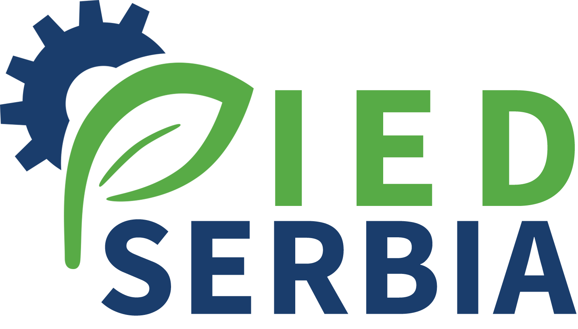

Further Implementation of the Industrial Emissions Directive in Serbia

Terms of Reference
Activity 2.1 Local STE – Water Management Expert

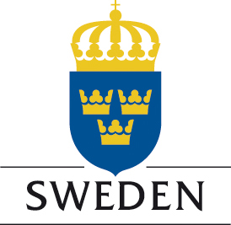

Project is funded by the Embassy of Sweden Belgrade

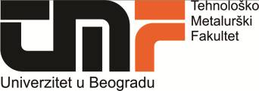



Project is implemented by the Cleaner Production Centre of the Faculty of Technology and Metallurgy University of Belgrade

Position: Local Short Term Expert – Activity 2.1 – Water Management Expert (ref. LSTE/water)

O

Description of the project

General objective of the project “Further Implementation of the IE Directive in Serbia” is to support the Serbian Competent Authorities and operators in the implementation of the IE Directive by carrying out a comprehensive analysis of the measures that operators have to implement in order to achieve full compliance with IED requirements. A special focus will be given to minimize the impact on environment of the Food production chain operators through specific consideration to measures related to energy and resources utilization. Additionally, the project will aim to foster technological improvement of operators in order to help them to comply their operation with best available techniques.

This will be achieved through 4 main components of the Project and different activities that will involve all relevant stakeholders:

Support in the preparation of the Directive Specific Implementation Plan (DSIP) for IED and environmental legislation related to IED implementation

Technical support – direct support to the competent authorities and operators from the food production chain in the process of issuing integrated permits by preparing manuals, applications and relevant plans and draft permits; creation of network and help desk for operators

Promotion of technological improvement - to foster the cooperation between Companies and University in order to promote environmental programs as well as to adopt innovative EU standards and develop new market opportunities; preparation of technology transfer projects

Awareness and capacity building – organization of visibility events and various working groups.

Description of the activity 2.1 – Preparation of a Manual for efficient use of water and energy

Food production industries have high consumptions of water and energy so they have the highest opportunities to optimize these supplies and save resources, according to the principles of IPPC. Within this activity experts will collect best practices in the field of efficient use of water and energy and analyse their potential application in industries present on Serbian territory. The analysis will consider water supply, use, possible re/use and waste water treatment aimed to recover material or water.

The manual prepared during this activity will also include some case studies based on technologies or techniques already put in place by Serbian companies in order to describe practical results obtained in the legal, natural and technical context of Serbia.

Job description:
- Analysis of BAT and emerging techniques for water management adopted in the IPPC food and beverage sector in Serbia
- Preparation of case studies based on best practices adopted by Serbian companies
- Preparation, in cooperation with international experts, of manual on efficient use of water and energy for operators of the food and beverage sector in Serbia

Period of the Assignment: December 2018 – September 2019

Number man/days allocated: a maximum of 60 working days during the period of the assignment

Location of the assignment: Belgrade and other towns of Serbia

Qualification and skills
Education | University degree in Technical Sciences, mechanical or chemical engineering. A PhD in a subject relevant to the assignment is an advantage
Education | At least very good command of English (2 on a scale 1-5 where 1 is excellent)
Professional Experience | - At least 10 years of post graduate professional experience in water management  - Experience in design or control of water management technologies in the industry (food and beverage is considered as an advantage)  - Experience in development of similar guidance and toolkits  - Work experience in the projects in the fields related/similar to the contract is considered as an advantage

