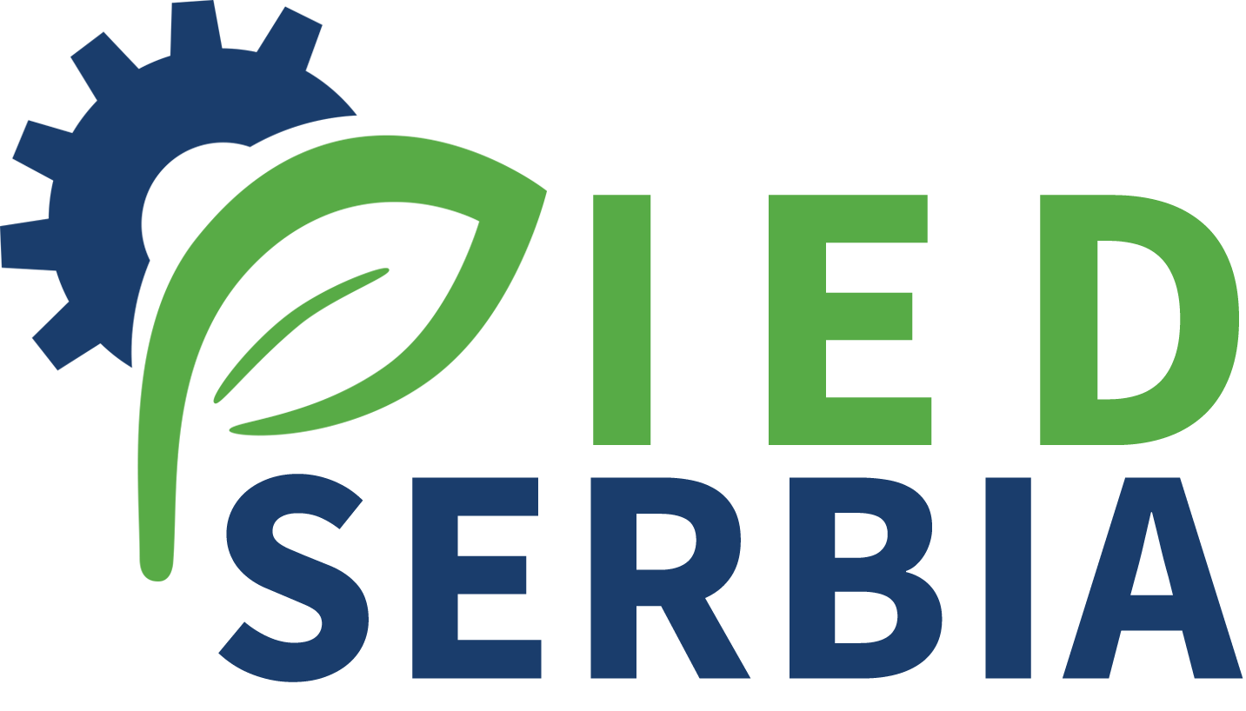

Further Implementation of the Industrial Emissions Directive in Serbia

Terms of Reference
Activity 3.1/3.2 Local STE – Environmental projects Expert

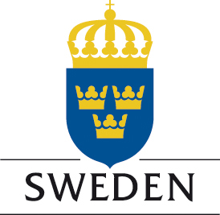

Project is funded by the Embassy of Sweden Belgrade

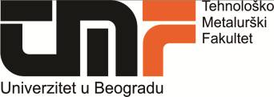



Project is implemented by the Cleaner Production Centre of the Faculty of Technology and Metallurgy University of Belgrade

Position: Local Short Term Expert – Activity 3.1/3.2 – Environmental projects Expert (ref. LSTE/proj)

O

Description of the project

General objective of the project “Further Implementation of the IE Directive in Serbia” is to support the Serbian Competent Authorities and operators in the implementation of the IE Directive by carrying out a comprehensive analysis of the measures that operators have to implement in order to achieve full compliance with IED requirements. A special focus will be given to minimize the impact on environment of the Food production chain operators through specific consideration to measures related to energy and resources utilization. Additionally, the project will aim to foster technological improvement of operators in order to help them to comply their operation with best available techniques.

This will be achieved through 4 main components of the Project and different activities that will involve all relevant stakeholders:

Support in the preparation of the Directive Specific Implementation Plan (DSIP) for IED and environmental legislation related to IED implementation

Technical support – direct support to the competent authorities and operators from the food production chain in the process of issuing integrated permits by preparing manuals, applications and relevant plans and draft permits; creation of network and help desk for operators

Promotion of technological improvement - to foster the cooperation between Companies and University in order to promote environmental programs as well as to adopt innovative EU standards and develop new market opportunities; preparation of technology transfer projects

Awareness and capacity building – organization of visibility events and various working groups.

Description of the activity 3.1/3.2 – Promotion of technological improvement in the food production chain

The activity is aimed to support operators and other stakeholders in the identification of funding opportunities and preparation of project proposals to foster innovation in the field of environmental protection.
A comprehensive analysis of the ongoing environmental programmes will be prepared, as well as a survey on the projects currently in place or planned by the involved companies. The activity will include a SWOT analysis of the potential projects involving technological improvement in the food production chain in Serbia considering topics like energy efficiency, water usage and management, waste water treatment, waste or by-products recycling and re-use. In the analysis of potential projects, the experts will make sure that the outcomes are in line with the IED requirements and that implementation of identified projects will help operators to comply with BAT and related ELVs. The project will identify some environmental projects involving companies from the food production chain and potential funding programs to carry them out. A list of project proposals will be prepared in order to be ready for the application for funds (Demo Environment, Innovation Fund, H2020, Erasmus+, Green Fund, other programs) once specific calls will be published. In particular, a specific connection with the Swedish funding programme Demo Environment will be established in order to bring Serbian companies to preparedness for submitting their application for the funds and introduce in Serbia new and up-to-date technologies.

Job description:
- Report on the current status of environmental projects in the food processing chain in Serbia, including an overview of the technological level related to environmental protection
- Support to the international experts in the preparation of a SWOT analysis identifying clear strengths and opportunities of technological improvement in the food processing chain
- Preparation of a list of potential project ideas in the field of innovation for environmental protection in the food and beverage sector in Serbia
- Support to the international expert in the preparation of 3 project proposals ready for the application to specific funds

Period of the Assignment: June 2018 – June 2020

Number man/days allocated: a maximum of 60 working days during the period of the assignment

Location of the assignment: Belgrade and other towns, Serbia

Qualification and skills
Education | University degree in Technical Sciences, Agriculture, Environmental Management or equivalent subject. A PhD in a subject relevant to the assignment is an advantage
Education | At least very good command of English (2 on a scale 1-5 where 1 is excellent)
Professional Experience | - At least 5 and preferably 6 years of post graduate professional experience in environmental projects preparation or management  - Experience with preparation of applications for EU and other funds  - Work experience in the projects in the fields related/similar to the contract is considered as an advantage

