

Further Implementation of the Industrial Emissions Directive in Serbia

Terms of Reference
Activity 4.1 Local STE – Communication Expert

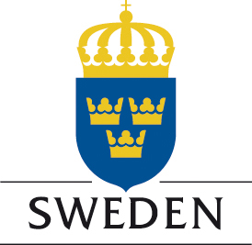

Project is funded by the Embassy of Sweden Belgrade

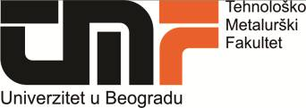



Project is implemented by the Cleaner Production Centre of the Faculty of Technology and Metallurgy University of Belgrade

Position: Local Short Term Expert – Activity 4.1 – Communication Expert (ref. LSTE/comm)

O

Description of the project

General objective of the project “Further Implementation of the IE Directive in Serbia” is to support the Serbian Competent Authorities and operators in the implementation of the IE Directive by carrying out a comprehensive analysis of the measures that operators have to implement in order to achieve full compliance with IED requirements. A special focus will be given to minimize the impact on environment of the Food production chain operators through specific consideration to measures related to energy and resources utilization. Additionally, the project will aim to foster technological improvement of operators in order to help them to comply their operation with best available techniques.

This will be achieved through 4 main components of the Project and different activities that will involve all relevant stakeholders:

Support in the preparation of the Directive Specific Implementation Plan (DSIP) for IED and environmental legislation related to IED implementation

Technical support – direct support to the competent authorities and operators from the food production chain in the process of issuing integrated permits by preparing manuals, applications and relevant plans and draft permits; creation of network and help desk for operators

Promotion of technological improvement - to foster the cooperation between Companies and University in order to promote environmental programs as well as to adopt innovative EU standards and develop new market opportunities; preparation of technology transfer projects

Awareness and capacity building – organization of visibility events and various working groups.

Description of the activity 4.1 – Communication strategy related to IED and connected Directives

The activity is aimed to increase operators’ and other stakeholders’ awareness of the principles and requirements provided by IED and innovation.

Two visibility events will be organized to disseminate the results of the project. Results will be also published in the project website, updated regularly by the project team.

Job description:
- Support to the project team in the preparation and continuous update of the project website
- Preparation of the promotional material (leaflets, brochures,..) for the communication campaign
- Media management during the organization of the visibility events and other workshops

Period of the Assignment: June 2018 – June 2020

Number man/days allocated: a maximum of 60 working days during the period of the assignment

Location of the assignment: Belgrade and other towns, Serbia

Qualification and skills
Education | University degree in Journalism, Filology or related matters
Education | At least very good command of English (2 on a scale 1-5 where 1 is excellent)
Professional Experience | - At least 5 years of post graduate professional experience in media management or journalism  - Experience in preparing communication strategies and material for relevant Authorities, operators and other target groups in the relevant field  - Proven knowledge of social media and web tools  - Work experience in the projects in the fields related/similar to the contract is considered as an advantage

