Further Implementation of EU Regulation on Volatile Organic Compounds

Terms of Reference
International STE – Legal Expert



This project is financially supported by
The Royal Norwegian Embassy in Belgrade
https://www.norway.no/en/serbia/

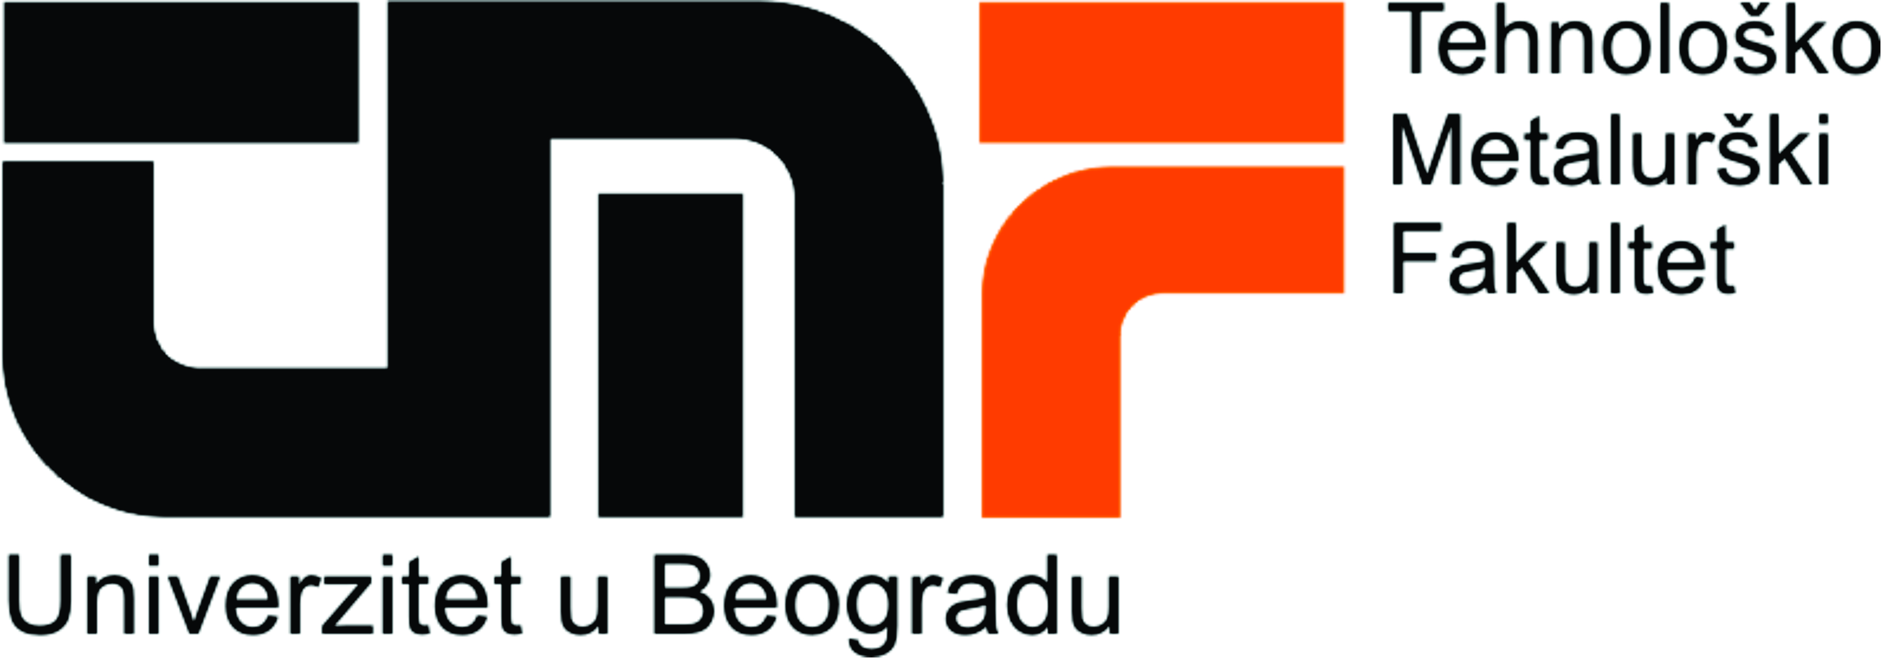


Project is implemented by the Cleaner Production Centre of the Faculty of Technology and Metallurgy
University of Belgrade

Position: International Short Term Expert – Legal Expert – Activity 1 (ref. InSTE/legal)

Description of the project
General objective of the project is to support the Ministry of Environmental Protection of the Republic of Serbia and the Serbian Agency for Environmental Protection in the implementation of Chapter V of Industrial Emissions Directive (IED) regarding pollution from operators utilizing Volatile Organic Compounds (VOC), in accordance with the implementation plan laid down within the process of access to the EU and negotiation Chapter 27.
The project aims to achieve the following specific objectives:
- Enhance the process of accession of Serbia to the EU supporting operators and Institutions in the transposition and implementation of specific requirements of Industrial Emissions Directive applicable to operators using Volatile Organic Compounds (VOC);
- Contribute to improve the capacity of Serbian's Ministry for Environmental Protection in governing and reducing the pollution derived from the use of VOCs;
- Foster socio-economic development of Serbian operators, particularly SMEs, by increasing their skills and capacity in the field of protection of the environment from VOCs and improving their competitiveness.
This project represents a further support to the Ministry of Environmental Protection (MEP) in carrying out the Implementation Plan for IED providing them with a functional IT system for reporting obligations and additional training needed to increase the capacity of operators and inspectors to fulfill their obligations according to Chapter V of IED.

Description of Activity 1 – Support for complete transposition of Chapter V of IED

The main aim of the activity is to support MEP in identifying the legal gaps of current Serbian legal framework related to VOCs and in preparing the necessary amendments and legal acts to achieve full compliance with Chapter V of IED. The activity will consider Laws and Regulations that are currently regulating this field in Serbia and assess them in accordance with the legal gap assessments prepared so far by MEP or previous projects. Amendments to the existing Laws and by-Laws as well as new Regulation will, then, be prepared in strict coordination with MEP. The outputs will be presented to the main stakeholders and finalized in accordance with the received comments in order to provide MEP with the possibility to start immediately the official process for their approval, coherently with the adopted National Plan for Approximation.

Job description:
  - Analysis of the legal Gap assessment on Chapter V of IED as updated by the LSTE;
  - Finalization of the set of amendments to Serbian legal framework necessary to fill the identified gaps with Chapter V of IED;
  - Finalization of the amended version of the Regulation on the activities using VOC.

Period of the Assignment: February 2019 – September 2019

Number man/days allocated: a maximum of 10 working days during the period of the assignment

Location of the assignment: Belgrade, Serbia and home-based

Qualification and skills
Education | University degree in Environmental Management or Law. A PhD in a subject relevant to the assignment is considered an advantage.
Education | At least very good command of English (2 on a scale 1-5 where 1 is excellent)
Professional Experience | - At least 10 years of post-graduate professional experience in environmental management  - At least 7 and preferably 8 years of post-graduate professional experience in transposition and implementation of environmental legislation  - Prior professional experience in the field of transposition and implementation of the EU acquis gathered in the country and the Balkan region  - Experience with implementation aspects of environmental legislation in the business sector and/or public institutions is considered as an advantage  - Work experience in the projects in the fields related/similar to the contract is considered as an advantage

